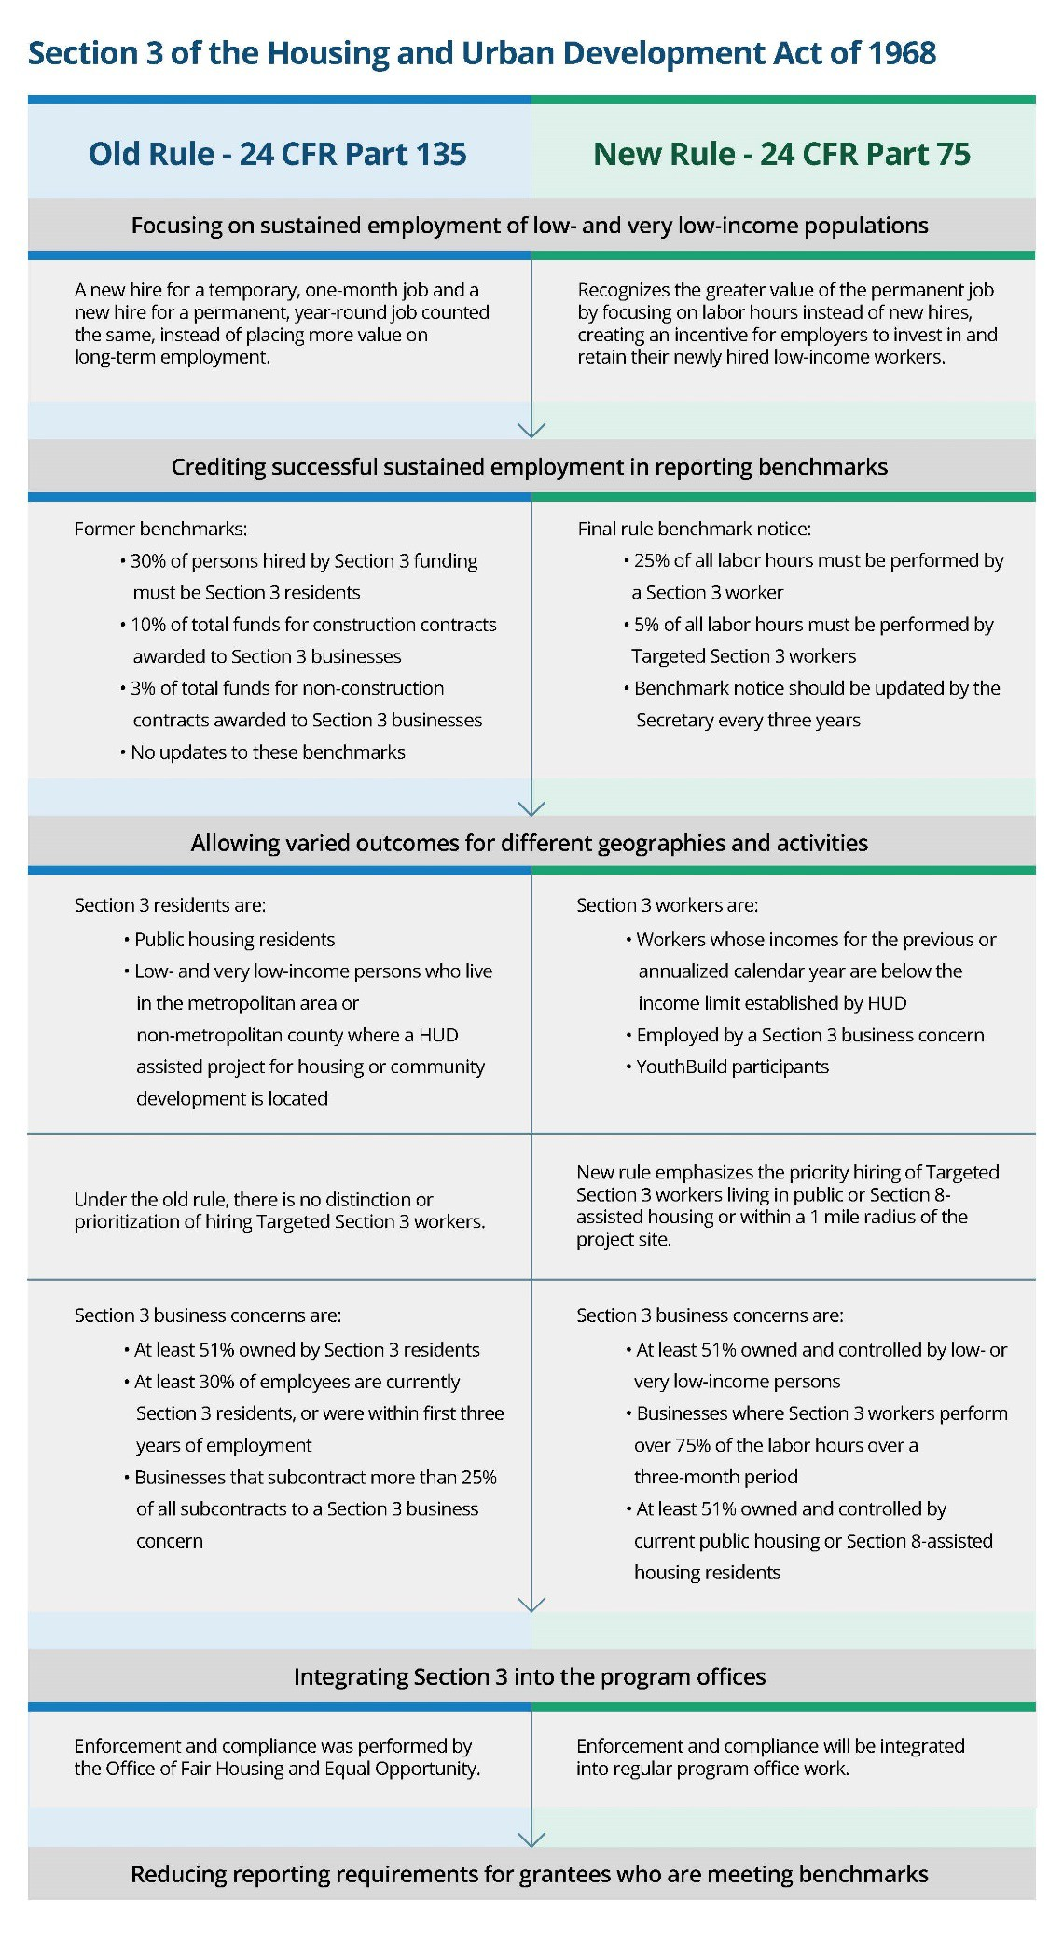
Exhibit 7-6 → Summary of the Key Changes of the New Rule

