Cost-Price Detail

(and instructions)
1 Cost Price Summary
- Summary Budget Tab
- Invoices Example
A Cost Component Detail sheet should be prepared for each task. The details will populate the Summary Budget Tab automatically.

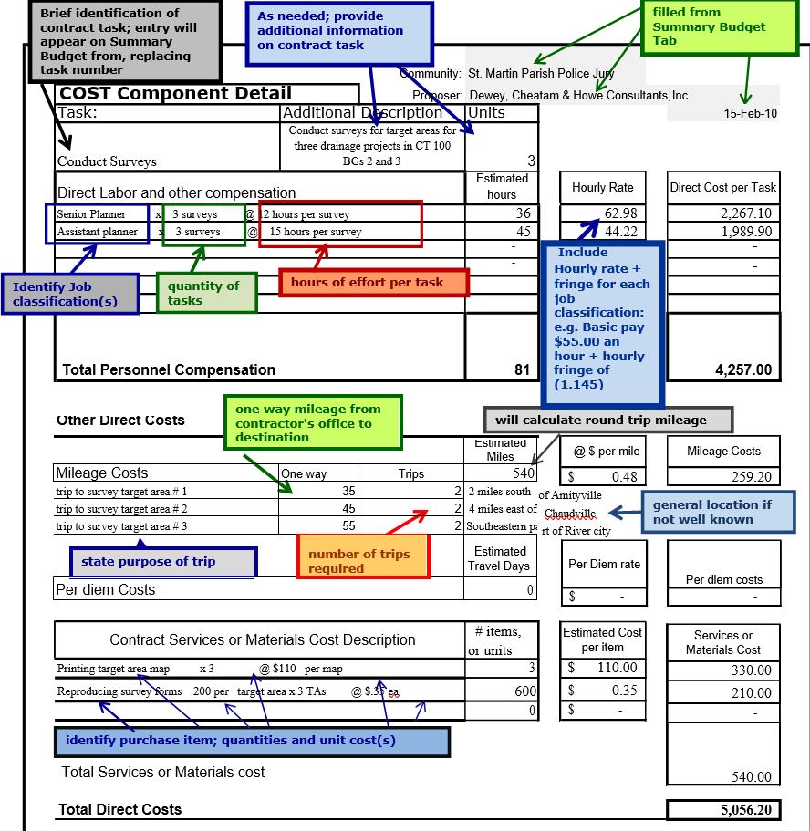

(Cost Component Detail Summary Continued)
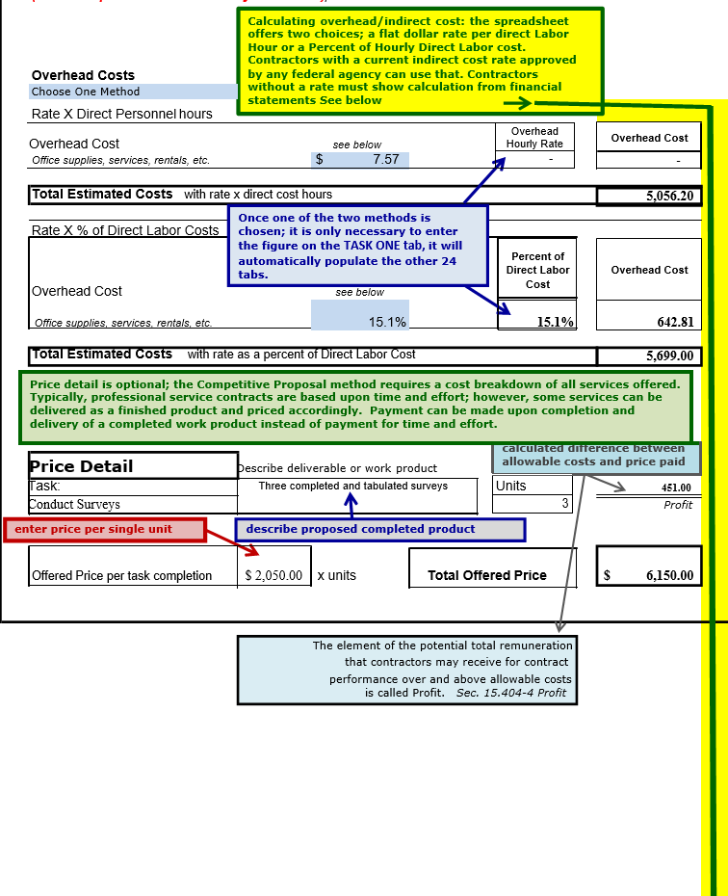

Cost-Price Detail
(and instructions)

EXAMPLE: Overhead/Indirect costs

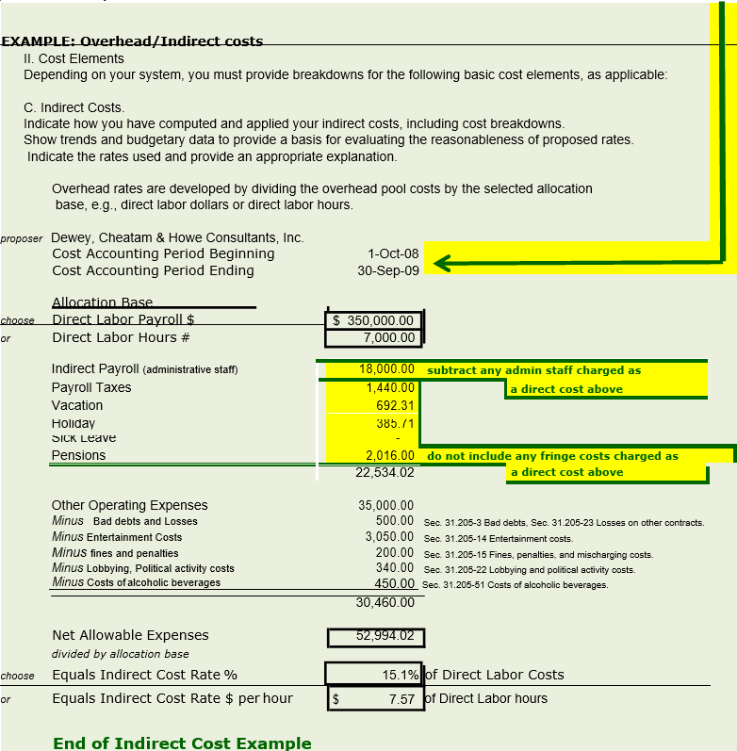

Summary Budget Tab

Part III Payment Schedule
Agreement between
St. Martin Parish Police Jury
and
Dewey, Cheatam & Howe Consultants, Inc.

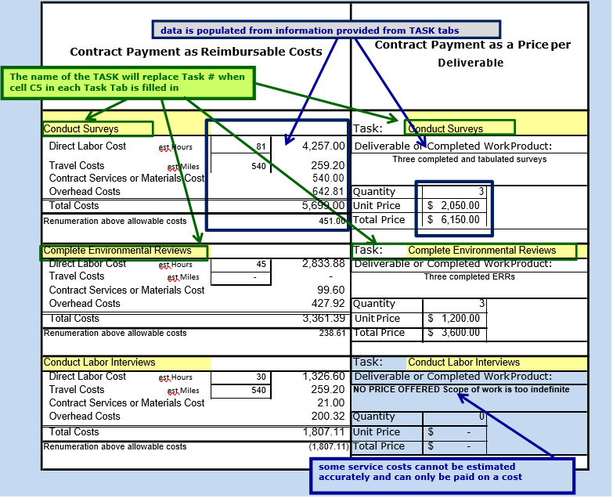

Cost-Price Detail and Instructions
EXAMPLE: Price/Deliverable Billing Invoice
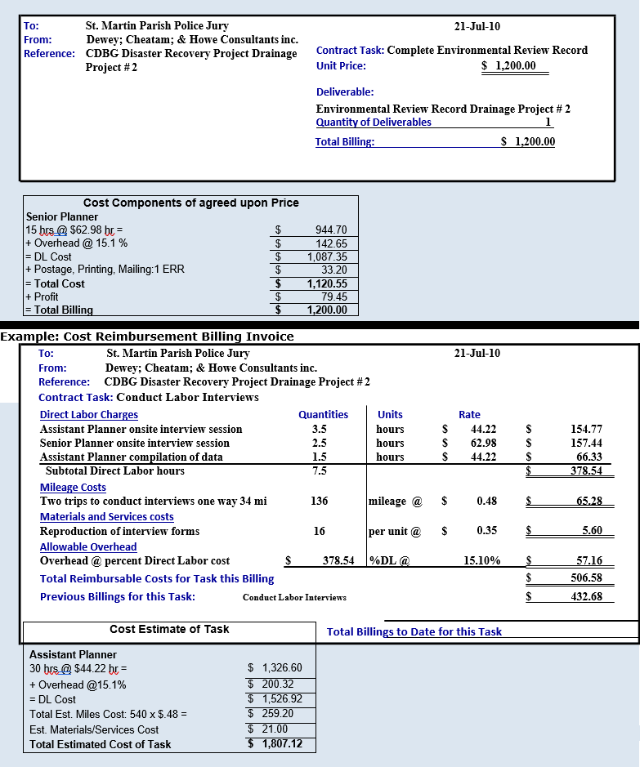

Cost-Price Detail
(and instructions)

COST COMPONENT DETAIL
Nothing in the following discussions should be interpreted as recommending the inclusion as direct costs any items normally treated as overhead costs in the firm’s accounting or estimating system. 48 CFR Part 31 identifies general cost principles applicable to subagreements with profit-making commercial organizations. OMB Circulars A-122 and A-87 are cost principles for nonprofit organizations and state/local governments, respectively.
Architect-engineer and construction contracts are also subject to 48 CFR Part 3 1.105.
Direct Labor
Direct labor-costs normally include salaries at a regular time rate. Overtime premiums should be identified separately on an attachment. Incurrence of unanticipated overtime costs requires the approval of the recipient at the time of incurrence. If significant overtime is known to be needed at the time of completion of the cost review form, the reasons therefore, labor categories, rates and hours should be identified on an attachment. Also included is the cost of partner’s or principal’s time when they are directly engaged in services to be rendered under the subagreement. In case the full time of any employee is not to be devoted to work to be performed under the subagreement, only the cost of actual time to be applied should be included. The compensation of a partner or principal shall be included as direct cost only for the time that she/he is expected to be engaged directly in the performance of work under the subagreement and only if it is the firm’s normal practice to charge such time directly to all jobs. The rate of compensation of a partner or principal shall be commensurate with the cost of employing another qualified person to do such work, but the salary portion shall not exceed the actual salary rate of the individual concerned. Distribution of profits shall not be included in the rate of compensation.
Enter the categories of professional or technical personnel necessary to perform each major element of work under the subagreement scope of services. Estimate hours worked for each category and extend them by the wage rates to be paid during the actual performance of the work. Current rates adjusted for projected increases, if any, should be used for the actual categories of labor contemplated. AR projected increases should be supported by recent experience or established personnel policy.

Supporting records to be maintained by the contractor and which must be submitted or made available to LOCD- DR upon request include:
- The method of estimating proposed hours worked.
- The computation technique used in arriving at proposed labor rates.
- The specific documents, books, or other records used as factual source material to develop proposed hours worked and labor rates.
- Detailed rate computations which were used in computing the information submitted on the form.
Indirect costs
Indirect costs may consist of one or more pools of expenses which are grouped on the basis of the benefits accruing to the cost objectives represented by the distribution base or bases to which they are allocated. Since accounting practices vary, the use of particular groupings is not required. Neither is the use of any particular allocation base mandatory. However, it is mandatory that the method used results in an equitable allocation of indirect costs to cost objectives which they support.

Normally, the firm's accounting system and estimating practices will determine the method used to allocate overhead costs. The firm's established practices, if in accord with generally accepted accounting principles and PROVIDED THEY PRODUCE EQUITABLE RESULTS IN THE CIRCUMSTANCES, will generally be accepted.

Cost-Price Detail
(and instructions)

Proposed overhead rates should represent the firm's best estimate of the rates to be experienced during the subagreement period. They should be based upon recent experience and be adjusted for known factors which will influence experienced trends.

Common overhead groupings are overhead on direct labor and general and administrative expenses. The first grouping usually includes employment taxes, fringe benefits, holidays, vacation, idle time, bonuses, etc., applicable to direct labor. The second generally includes the remaining costs which because of their incurrence for common or joint objectives are not readily subject to treatment as direct costs. It is expected, however, that proposal groupings will correspond with the firm's normal method for accumulating indirect costs. No special categorization is required provided the results are realistic and equitable.
Direct salaries are the normal distribution base for overhead costs, but in some circumstances other bases produce more equitable results. As in the case of overhead costs groupings, the method to be used will depend upon the firm's normal practices and the equity of the results produced in the circumstances.
In the case of multi-branch firms, joint ventures, or affiliates, it is expected that overhead costs applicable to the specific location(s) where work is to be based on cost data from the most recent fiscal periods updated to reflect changes in volume of business or operations.
Enter the indirect cost pools normally used by the firm for allocation of indirect costs. Enter the indirect cost rate for each pool and extend each one by the rate base to which it applies to arrive at the estimated indirect costs to be incurred during the actual performance of the work. If the direct labor total is not used as the rate base for any of the indirect cost pools, the rate base used must be explained on an attached sheet.
Describe the firm’s policies and practices for accumulating indirect costs. The indirect cost rate changes and the method used to compute the proposed rate or rates shall accompany the form. Include comment on the firm's policies regarding the pricing and costing of principal’s time. The normal accounting treatment of principal’s
salaries, the annual amounts, and the hourly charge rate, if used, should be discussed.
Supporting records to be maintained by the contractor and which must be submitted or made available to the recipient or LOCD-DR upon request include:
- Detailed cost data showing overhead accounts, allocation bases, and rate computations for the preceding fiscal period. If more than six months of the current fiscal period have elapsed, cost data for this period (first six months) should be included.
- Company budgets, budgetary cost data, and overhead rate computations for future period(s).
Pier Diem Costs
The following items are illustrative of costs normally included in this category of costs:
a. Travel costs, including transportation, lodging, subsistence, and incidental expenses incurred by personnel or consultants while in a travel status in connection with the performance of services required by the contract. The cost principles generally require the use of less than first class air accommodations and
also limit the cost of private aircraft.
b. Equipment, Materials, and Supplies
(1) Long distance telephone, telegraph and cable expenses to be incurred in connection with the
performance of services required in connection with the contract.
(2) Reproduction costs including blueprints, black and white prints, ozalid prints, photographs,
photostats, negatives, and express charges.
(3) Commercial printing, binding, artwork, and models.
- Subcontracts.
- Other. Direct costs, if there are any, not included above.
Enter all other direct costs proposed. Travel costs entered must be supported by an attachment which identifies the number of staff trips proposed and the estimated cost per staff trip for both local and long-distance transportation. The number of days and the rate per day must be provided to support the per diem shown. Each
subcontract and consultant agreement must be identified separately.
Supporting data to be maintained by the contractor and which must be submitted or made available to the
recipient or LOCD-DR upon request include:
a. Basis for other direct costs proposed.
b. Factual sources of costs, rates, etc., used in computing proposed amount of each cost element.
Profit

a. degree of risk,
b. Nature of the work to be performed,
c. Extent of firm's investment,
d. Subcontracting of work, and
e. Other criteria.
The Federal Acquisition Regulation cost principles applicable to subagreements with profit-making organizations (48 CFR Part 31.2 and 31.105) disallow certain types of costs which are sometimes incurred by firms in the normal conduct of their business. Examples of costs which are not allowed under these cost principles include, but are not limited to, entertainment, interest on borrowed capital, and bad debts. Because the Government considers "profit" to be the excess of price over allowable costs, such computation can indicate a higher profit estimate than the firm's experienced profit as it customarily computes it. The contractor may separately disclose to the recipient its customary computations.

Cost-Price Detail
(and instructions)

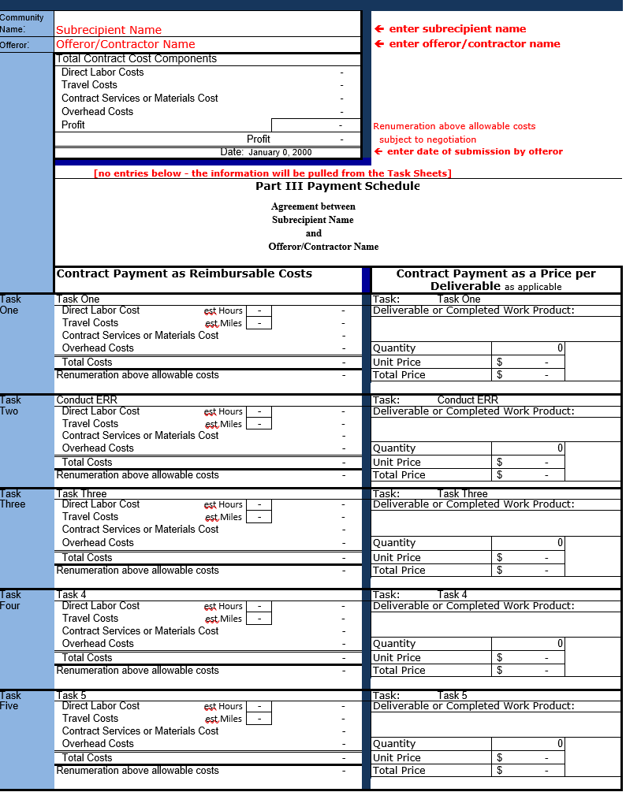

Cost-Price Detail
(and instructions)

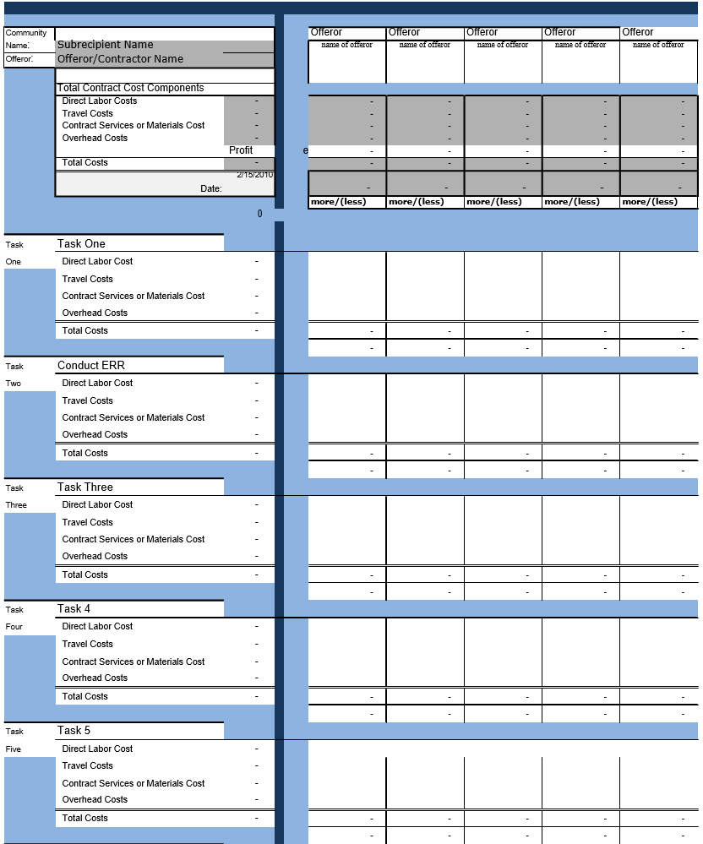

Cost-Price Detail
(and instructions)
