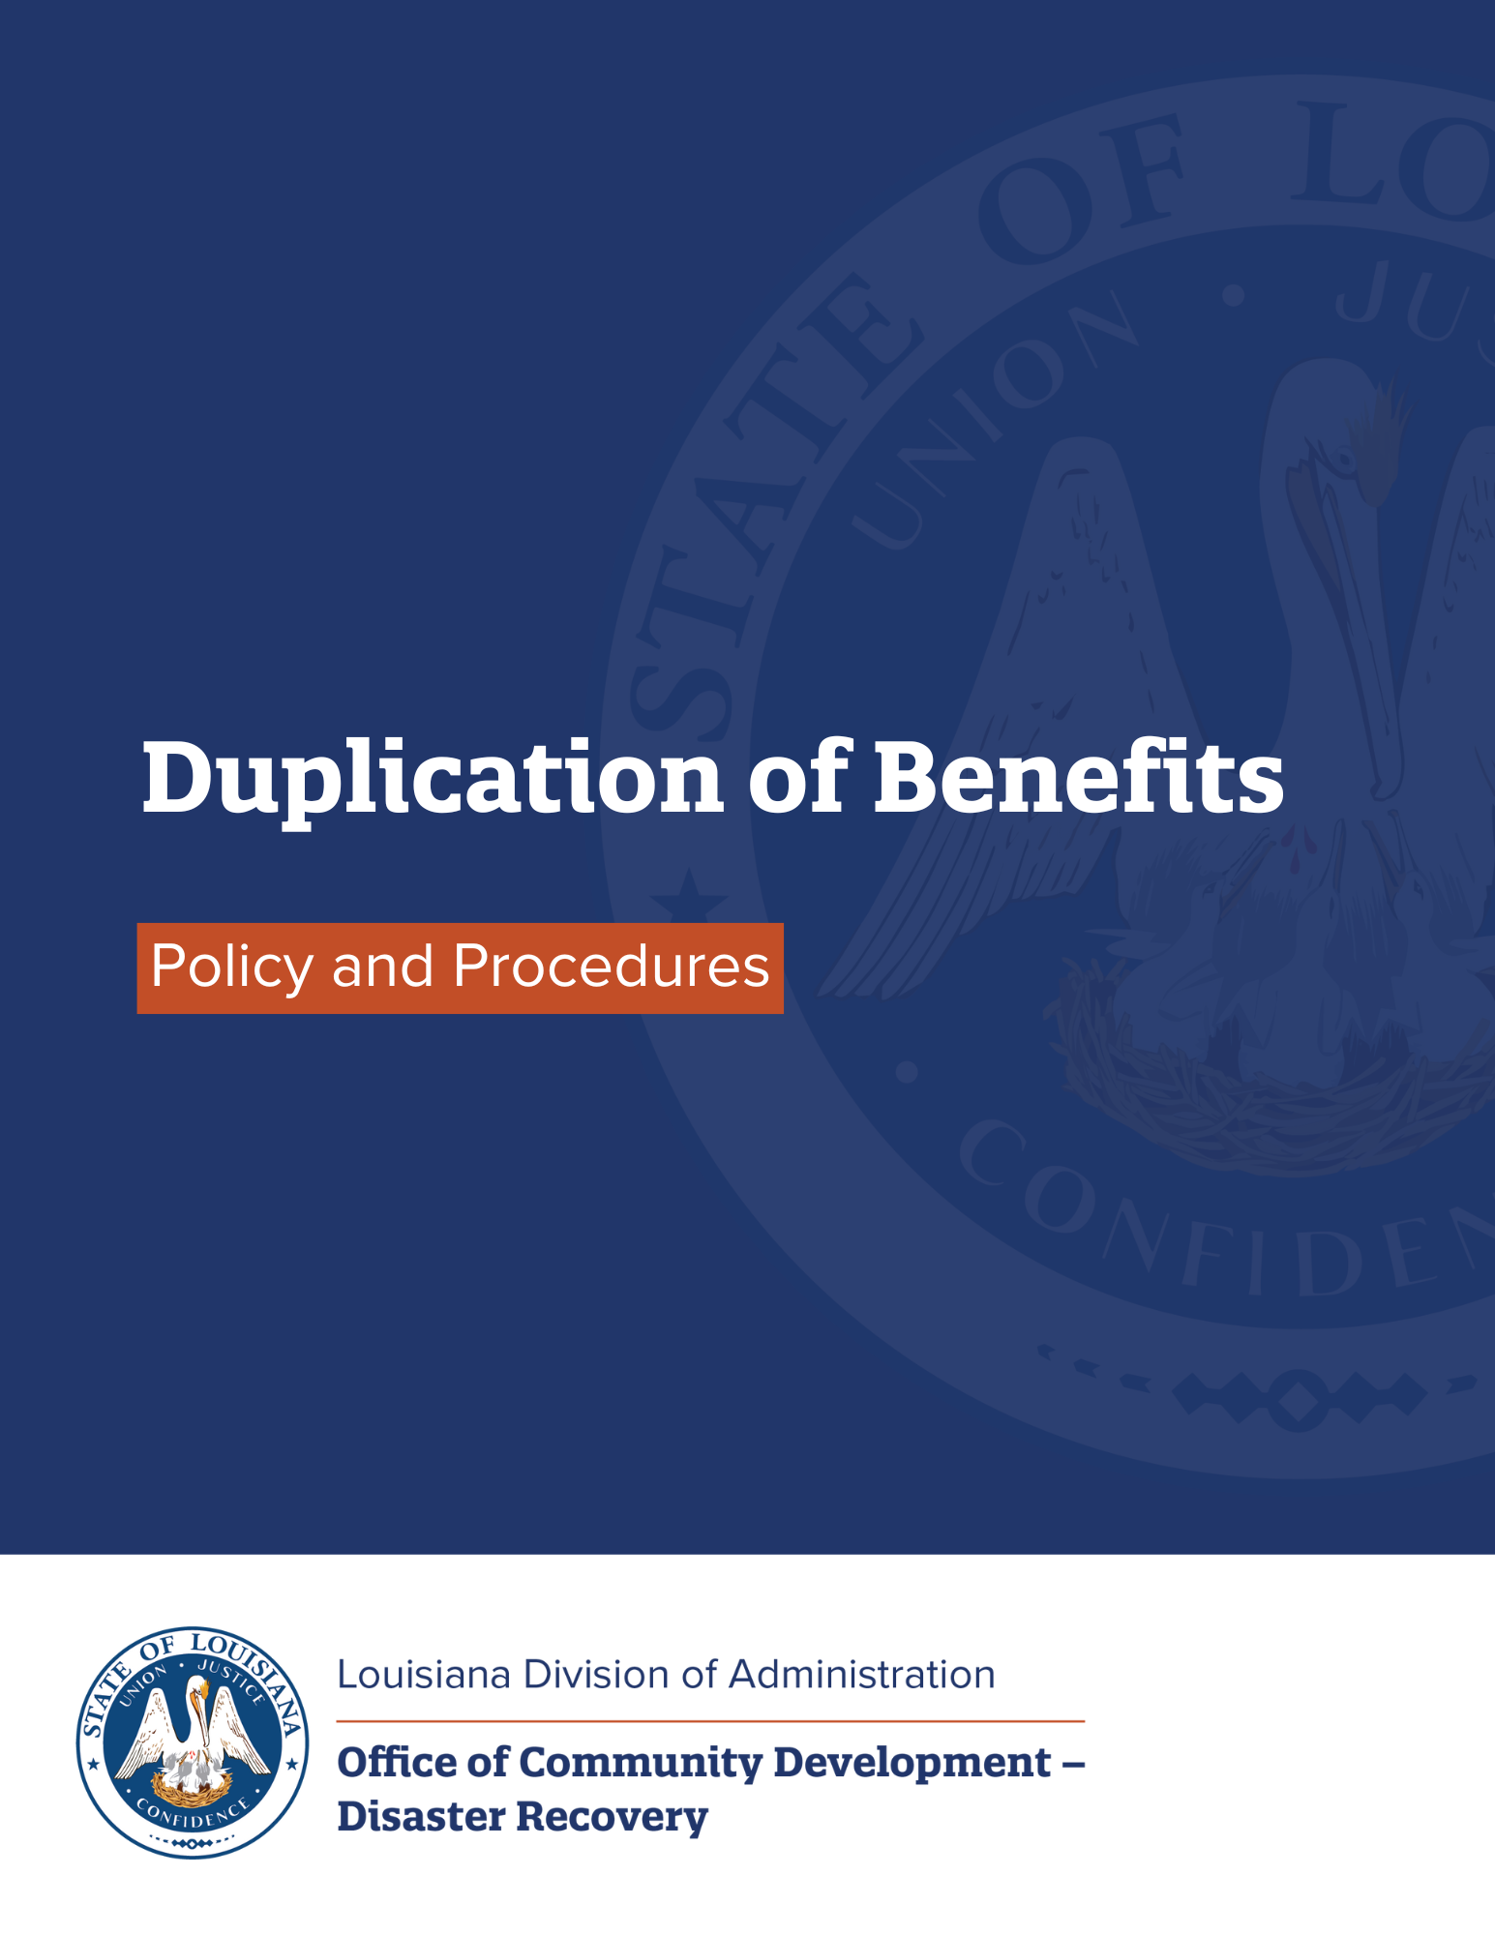

Duplication of Benefits Policy and Procedures

Overview
The Robert T. Stafford Disaster Relief and Emergency Assistance Act outlines the Federal government’s role in preparing for, and recovering from, a disaster. The Stafford Act requires federal funding recipients to make sure no "person, business concern or other entity" receives duplicative assistance. A duplication of benefits occurs when a person, household, business, or other entity receives disaster assistance from multiple sources for the same recovery purpose and the total assistance received for that purpose is more than the total need.
The State of Louisiana receives disaster assistance from the U.S. Department of Housing and Urban Development's (HUD) Community Development Block Grant (CDBG) Program. This assistance must supplement – not replace – other resources provided for the same need. For example, if a family's damaged home costs $100,000 to repair and the homeowner received insurance proceeds in that amount, the homeowner could not also receive federal disaster recovery funds to repair the home. Subrecipients should assure that each program provides assistance to a person or entity only to the extent that the person or entity has a disaster recovery need that has not been fully met by funds that have already been paid, or will be paid, from another source.

Procedure
Subrecipients must complete a duplication of benefits analysis for each applicant because disaster assistance varies widely.
The purpose of this document is to outline how the state of Louisiana's Office of Community Development – Disaster Recovery (LOCD-DR) assures that all applications for assistance from the programs it funds – as well as all projects implemented by LOCD-DR subrecipients, contractors, and sub-recipients – will be reviewed for possible duplication of benefits. The procedures described below are also applicable to all LOCD-DR subrecipients and sub-recipients and must be incorporated in the design and administration of programs/projects undertaken by them. This document details LOCD-DR's general Duplication of Benefits policy. Individual programs may be subject to program specific policies implementing additional Duplication of Benefits requirements or processes, subject to this overarching policy.
The LOCD-DR Program Manager is responsible for ensuring that the following steps are performed using the best reasonably available data from the Federal Emergency Management Agency, Small Business Administration, the National Flood Insurance Program, insurers, and other sources of assistance to verify all reasonably identifiable sources of recovery assistance received by or available to the applicant prior to any award.
The first step of the DOB determination (calculation) is to determine the amount of assistance needed and the amount of funds previously received – or to be received – for a particular disaster recovery activity. This is accomplished by first determining the applicant's post-storm disaster need prior to the receipt or potential receipt of other funds. Next, all other sources of recovery assistance received, or available to be received, must be disclosed during the application process and must be verified where reasonably possible. Other sources of funds can include, but are not limited to:
- Private insurance
- The Federal Emergency Management Agency
- The Small Business Administration
- The National Flood Insurance Program
- Local and state funds; other federal programs
- Private and nonprofit organizations
Whether the assistance constitutes a duplicative source can be effected by the use for which it was provided and specific exemptions that may be provided by law, regulation, or waiver, such as provided in the Disaster Recovery Reform Act, Public Law 115-254, which impacts SBA loans for certain presidentially declared disasters.
The next step is to identify assistance that is not available for the activity. This consists of:
- Funds received that are not for the same purpose as the CDBG activity(s)
- Funds not available to the applicant (e.g., forced mortgage payoff, contractor fraud, etc.)
- Funds from unsubsidized private loans (forgivable loans are duplicative)
- Funds from any other asset or line of credit available to the applicant, such checking and savings accounts, stocks, and so on
These funds are not considered to be duplicative and may be excluded and not deducted as a duplication of benefit. Finally, after subtracting from the proposed activity cost the duplicate funds received or available to receive, the maximum CDBG award is calculated.
Once the maximum CDBG award has been determined, applicants will be required to sign an agreement – either included in a grant/sub-recipient agreement or a separate subrogation instrument – requiring them to return to LOCD-DR any assistance received for the same purpose as the CDBG disaster recovery funds. This agreement is to be monitored by LOCD-DR program staff, subrecipients, and sub-recipients at least annually for three years. Unless an additional need is established, disaster recovery funds should be recaptured to the extent that they are in excess of the need and duplicate other assistance received by the beneficiary for the same purpose.
The following is an example of the above described process steps for DOB determination:
- Identify the Applicant’s Total Need Prior to Any Assistance $100,000
- Identify All Potential Duplicative Assistance $35,000
- Deduct Assistance Determined to be Duplicative $30,000
- Maximum Eligible Award (Item 1 less Item 3) $70,000
- Program Cap (if applicable) $50,000
- Final Award (lesser of Items 4 and 5) $50,000

Unmet needs
Disaster recovery assistance needs are calculated at one point in time. As a result, subsequent circumstances may occur that affect the need. If after the assistance has been calculated and/or a CDBG award has been made, an applicant can demonstrate a change in circumstances, the award calculation may be subsequently reevaluated to take the increased need into consideration. Such changes in circumstance include:
- Vandalism
- Contractor fraud
- Increased cost of materials and labor
- Change in local zoning law or building codes
- Damage to a partially repaired structure
However, the reevaluation must be done before the initial need for which assistance was granted has been fully met. For example, before a damaged house is fully repaired.
The federal regulation pertaining to this policy is found in 76 FR 71060, November 16, 2011 – as modified by 4 84 FR 28836 and 28848, June 20, 2019. Review these regulations when determining duplication of benefits. Caution should be utilized in determining the applicability of these federal notices with respect to an appropriation's funding of a specific program because these notices contain time restrictions.

Monitoring
The process for identifying and then monitoring for DOB begins with the review of each grant application – whether it is for a specific project or an individual beneficiary of disaster recovery CDBG funds. An applicant must provide detailed information about other sources of funds that were received – or that may be received – related to the activity for which CDBG funds are being requested. LOCD-DR or contracted program management staff review and verify the other funds to determine if they are for the same activity and exceed the need for recovery assistance. Once CDBG funds are awarded (minus any determined to be a DOB), applicants are required to notify LOCD-DR of the receipt of any additional funds received for the same activity. Program staff review individual pay requests and project amendments to determine if other funds have been received that represent a DOB. In the event that additional funds are determined to be a DOB, funds will be withheld from future pay requests, and the approved project budget will be amended. In the event that all funds have been expended and a DOB is identified, the applicant will be required to repay the funds to LOCD-DR for return to the U.S. Treasury. Monitoring for duplication of benefits will also be incorporated into LOCD-DR monitoring policies and procedures.

Responsible Party
The Program Director is responsible for Duplication of Benefits for both CDBG-DR and CDBG-MIT grants and may be contacted at 225-219-9600.

Subrogation agreements in programs run by subrecipients would require repayment to the subrecipient.

